**3 C - Synthesis of BIODIESEL**

Biodiesel is a fuel derived from vegetable oils and fats with similar combustion properties to regular diesel fuel. Regular diesel fuel is a mixture of hydrocarbons obtained by distillation of crude oil. Diesel is composed of about 75% [saturated hydrocarbons](http://en.wikipedia.org/wiki/Hydrocarbon#Types_of_hydrocarbons) (straight chained and branched), and 25% aromatic hydrocarbons (mainly alkyl benzenes). The average chemical formula for common diesel fuel is C12H23 – but the molecules in diesel range from C10 to C15.

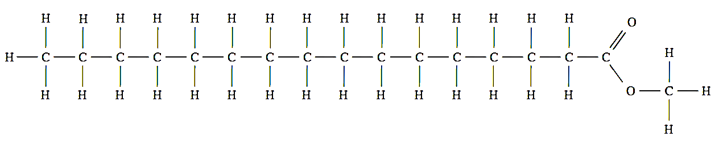Biodiesel is a mixture of long chain esters. The structure of a typical biodiesel molecule is shown below. The substituent group is either ethanol (cheaper) or methanol (higher yield), but the chain length and degree of saturation in the chain can vary.

Biodiesel can be produced in a number of ways, although for commercial production, one particular method (transesterification) is preferred due to commercial considerations (cost and efficiency).

The simplest way of producing a biodiesel molecule is by reacting a long chain carboxylic acid with methanol, to produce a long chain ester. This simple chemical reaction is called **esterification**. This reaction is not a preferred method for producing biodiesel, as long chain carboxylic acids (also known as fatty acids) are generally chemically combined with glycerol within fats and oils, and do not exist as separate molecules.



+

→

On an industrial scale, biodiesel is produced by the transesterification of the triglycerides found in fats and oils. Triglycerides consist of three long chain fatty acids (long chain carboxylic acids) which are chemically combined to glycerol via ester groups.

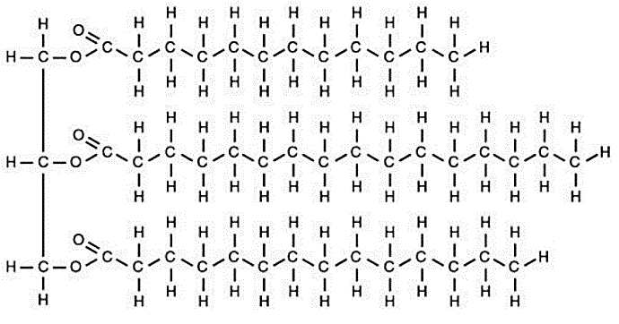

Glycerol unit

Ester links

3 Fatty acids

**A fat molecule.** Note that all the fatty acids in this molecule are saturated. In Oils, there is often a degree of unsaturation (double C to C bonds). The length of the chain can vary.

Biodiesel can be produced from oil-yielding crops or relatively clean waste oil. It is biodegradable and non-toxic, and combustion produces significantly fewer emissions than petroleum-based diesel, however it generally produces less power than petroleum diesel.

The process used to convert these oils to biodiesel is called **transesterification**. In transesterification, the triglyceride is reacted with methanol or ethanol to produce 3 esters (from the fatty acids parts) and glycerol.

The esters produced are separated to become biodiesel. The transesterification process can be done in two ways – as a base catalysed process, or an enzyme (Lipase) catalysed process.

**Base Catalysed Transesterification**

In the base catalysed transesterification process the reaction is carried out under low temperature and pressure. The base (proton acceptor) deprotonates the alcohol (CH3OH → CH3O-) to increase the rate of the reaction between the alcohol and the triglyceride (transesterification). Both products of the reaction (Biodiesel and glycerol) are commercially valuable. Base catalysed transesterification has been an industry standard, but does produces soaps as a by-product. This reduces the yield, and make separation of the products (glycerol is a valuable by-product) more difficult and expensive.

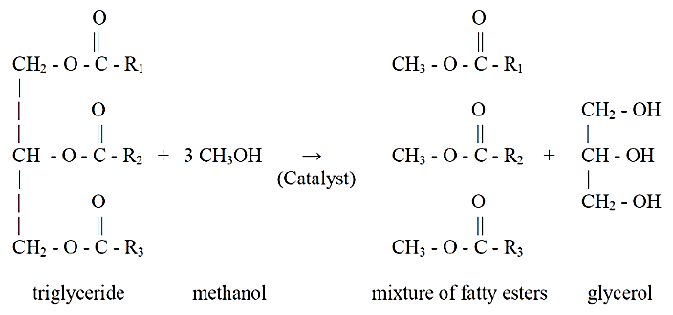

NaOH

→

(Base catalyst)

**Lipase Catalysed Transesterification**

A second transesterification process uses the enzyme Lipase to catalyse the reaction and also occurs at low temp and pressure. The lipase catalyses the breakdown of the triglycerides into fatty acids and glycerol. This method is more expensive (lipase enzyme is much more expensive than bases), and slower. However it is a more environmentally friendly synthesis process, and because no soap is produced, the yield and purity of the product is higher and separation of glycerol and biodiesel is simpler and less expensive.



Lipase

→

catalyst

Success criteria relating to Biodiesel

**SC 69** understand that reagents and reaction conditions are chosen to optimise the yield and rate for chemical synthesis processes, including the production of ammonia (Haber process), sulfuric acid (contact process) and biodiesel (base-catalysed and lipase-catalysed methods)

**SC 70** understand that fuels, including biodiesel, ethanol and hydrogen, can be synthesised from a range of chemical reactions including, addition, oxidation and esterification

**SC** **71** understand that enzymes can be used on an industrial scale for chemical synthesis to achieve an economically viable rate, including fermentation to produce ethanol and lipase-catalysed transesterification to produce biodiesel

**SC** **72** describe, using equations, the production of ethanol from fermentation and the hydration of ethene describe, using equations, the transesterification of triglycerides to produce biodiesel

**Make your notes so that these SC are covered. The Qs below pretty much cover what you need to know.**

**1. Identify the advantages and disadvantages of using lipase as a catalyst over a base catalyst in the synthesis of biodiesel. (SC69)**

**2. Explain the difference, using equations, between the production of biodiesel via esterification and production via transesterification. (SC 70 and 72)**